I Chauffeur

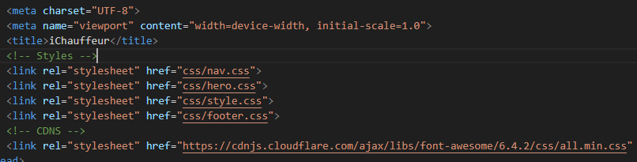

These are added in all the pages to maintain styles

**/index.html**



Navbar and hero section is inside this. When we want to use this in other page just change the image container class and ie; **image-container-ourcars**. And in that class copy the styles and change the background image

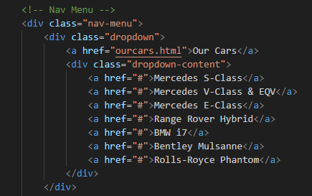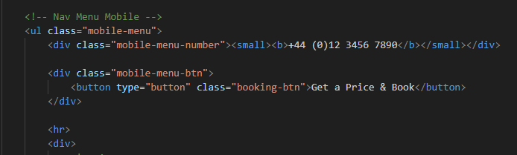

Nav-menu will show in the desktop when the screen size goes below 1029px then mobile-menu will show.

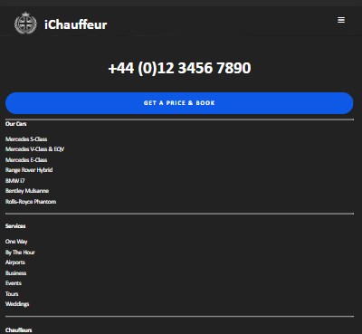

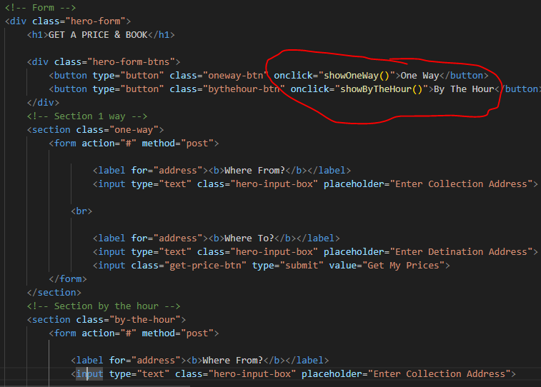

On Click will show the section with the forms. It uses the javascript. 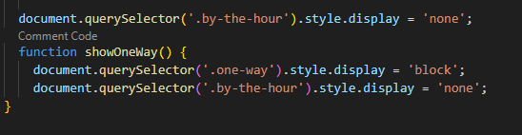

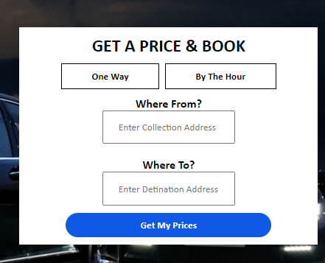

My Step by step process of changing the code.

.image-container-tours

Whenever making a new page rename and change the image in this class

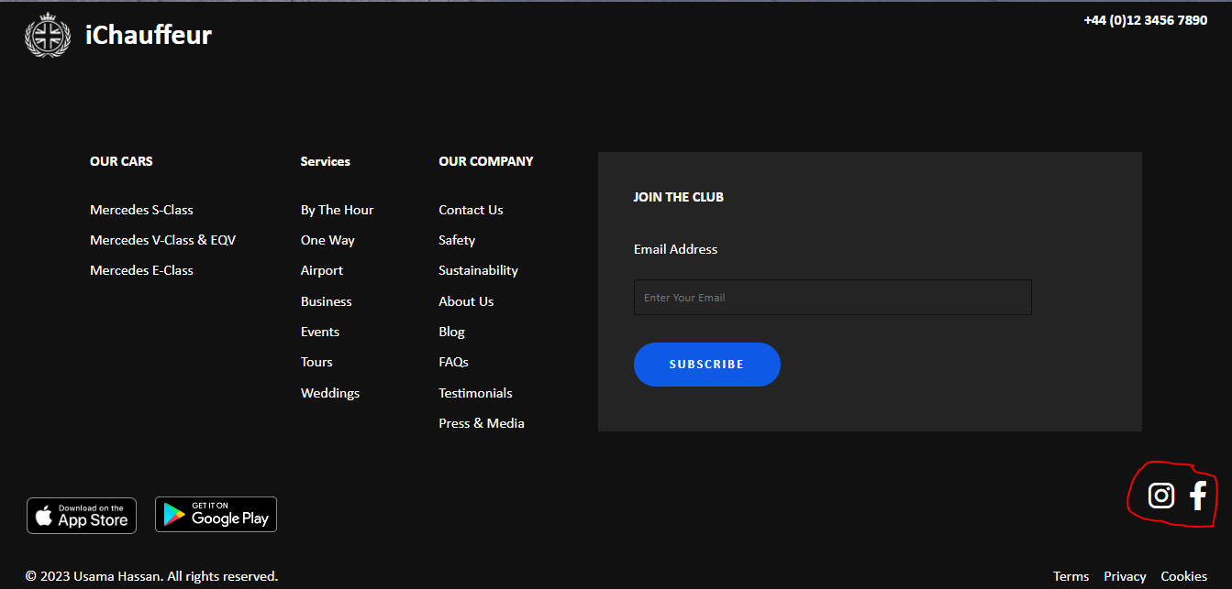

Footer section has this social Icons which is different for mobile view and will only be viewed in screen less than 1029px.

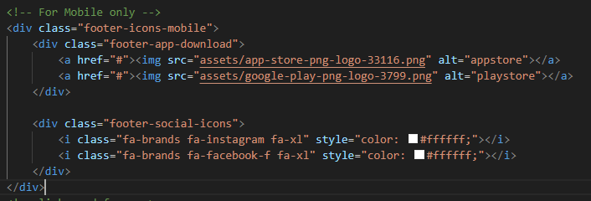

**/wedding.html**

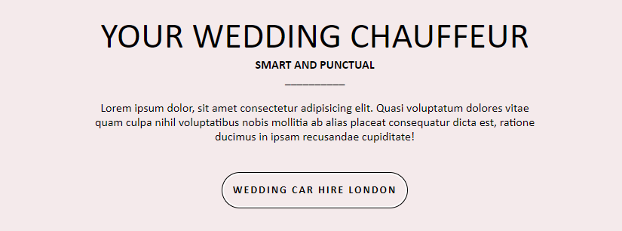

On weeding page I find this weeding car hire London to be useless because…

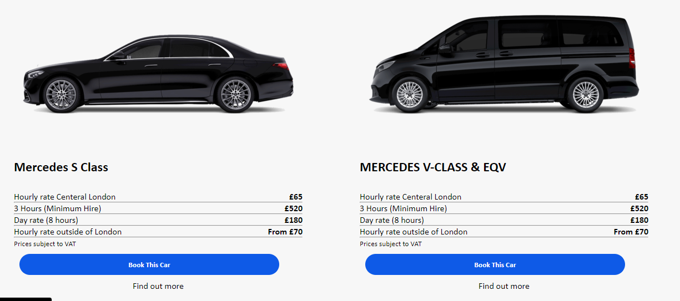

On the weeding page we can book the car on the same page so we don’t have to go on the other pages.

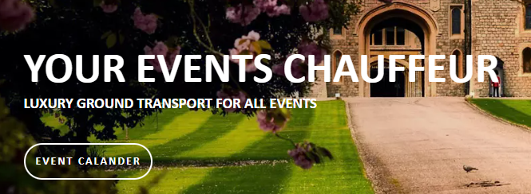

Change the heading and the buttons text in hero section

<div class="cars-guide-title" style="color: white;">

In most of the pages this div didn’t close, but the code works fine. Do not close the div

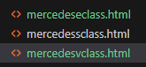 These there files are exact copy of each other

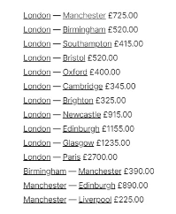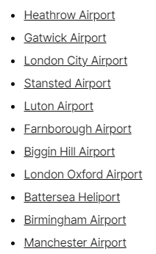

All will have same city page manchaster.html

All airports will have same page londonairport.html